Bhuvanesh L
23BTRCC009

Task 1: SQL – GROUP BY and HAVING
Create an Employees table with emp_id, emp_name, department, and salary. Insert at least 10 records across 4 or more departments. Write an SQL query to display departments that have more than 2 employees AND an average salary greater than ₹35,000. • Display department name, number of employees, and average salary. • Use GROUP BY, HAVING, COUNT(), and AVG(). Expected output: Only departments meeting both conditions.
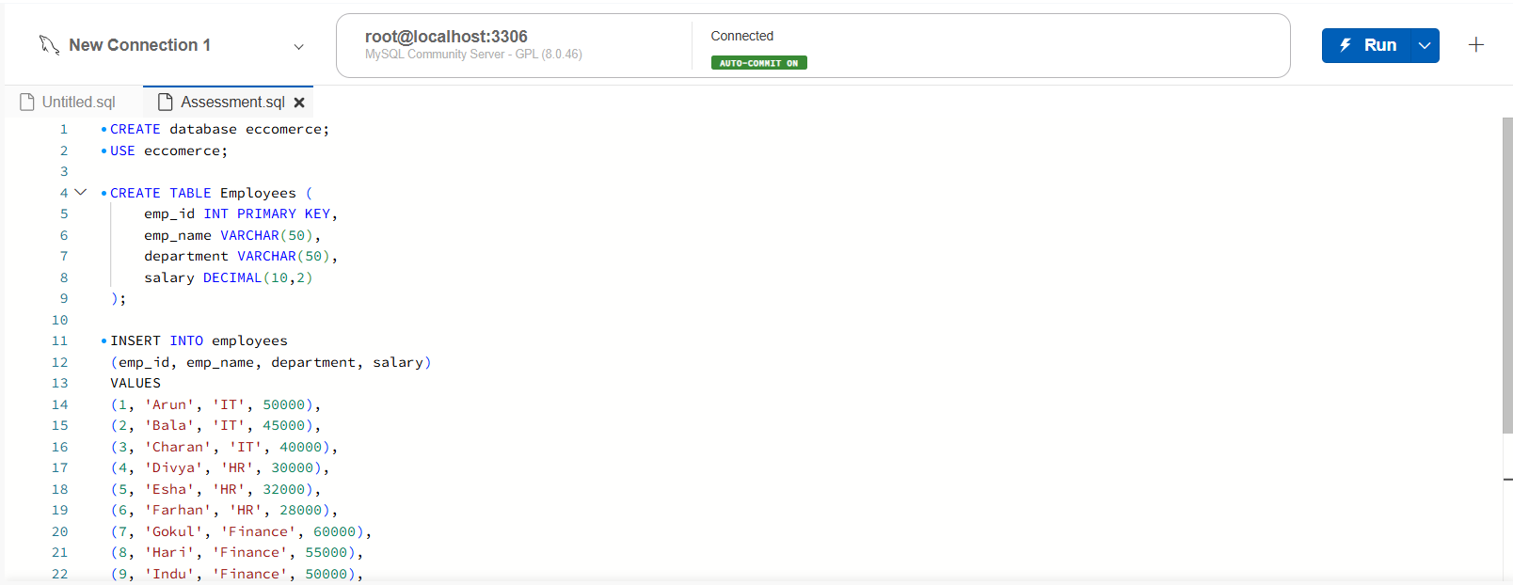

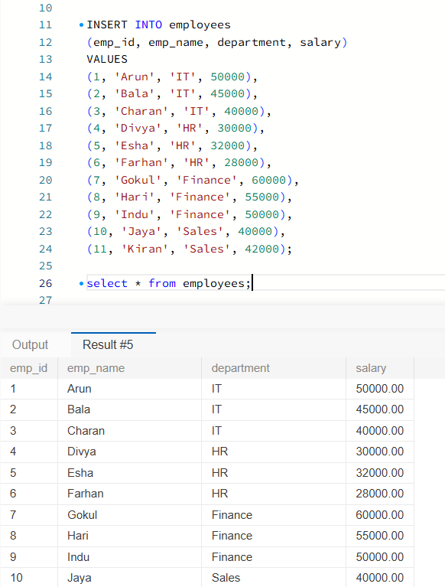

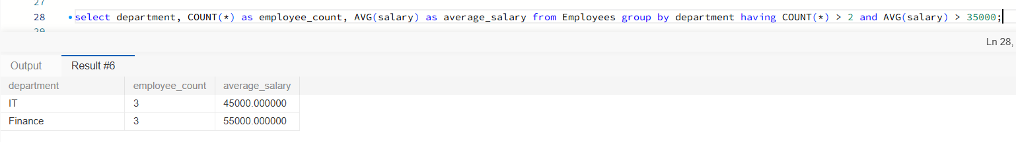

Task 2: Linux – File Content and Line Counting
Create numbers.txt, add five numbers with one number per line, display the file contents, and count the number of lines. Expected output: Five numbers and a line count of 5.
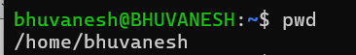

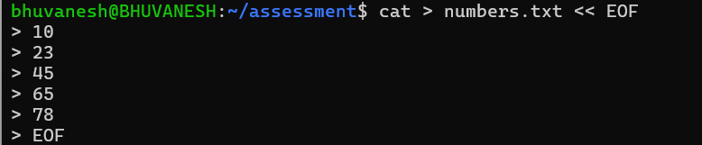

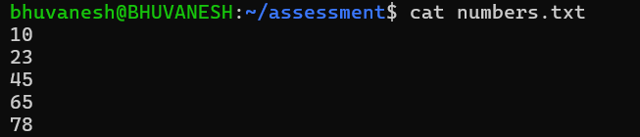

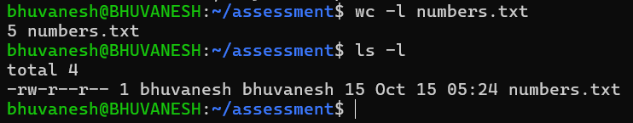

Task 3: AWS RDS – Database Configuration
Using an existing RDS database, identify the database engine, display the instance status, identify the endpoint and port, and demonstrate the connectivity configuration. If a database connection is available, connect and execute a simple SQL query. Expected output: Database configuration details and, if connected, the SQL query result.
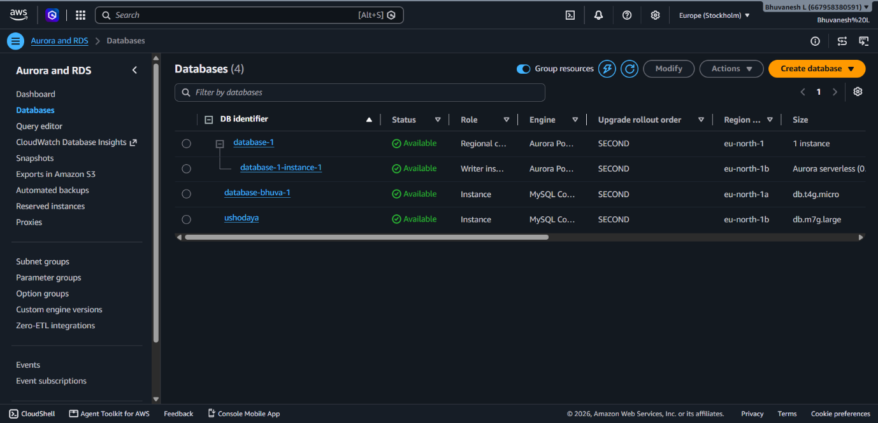

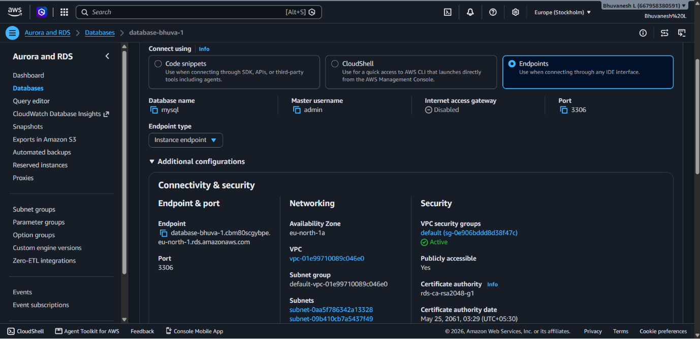

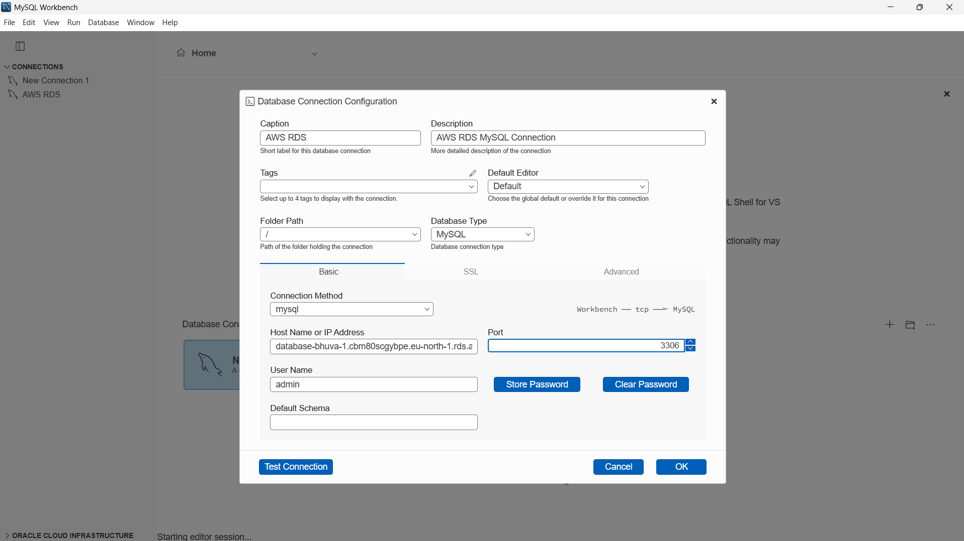

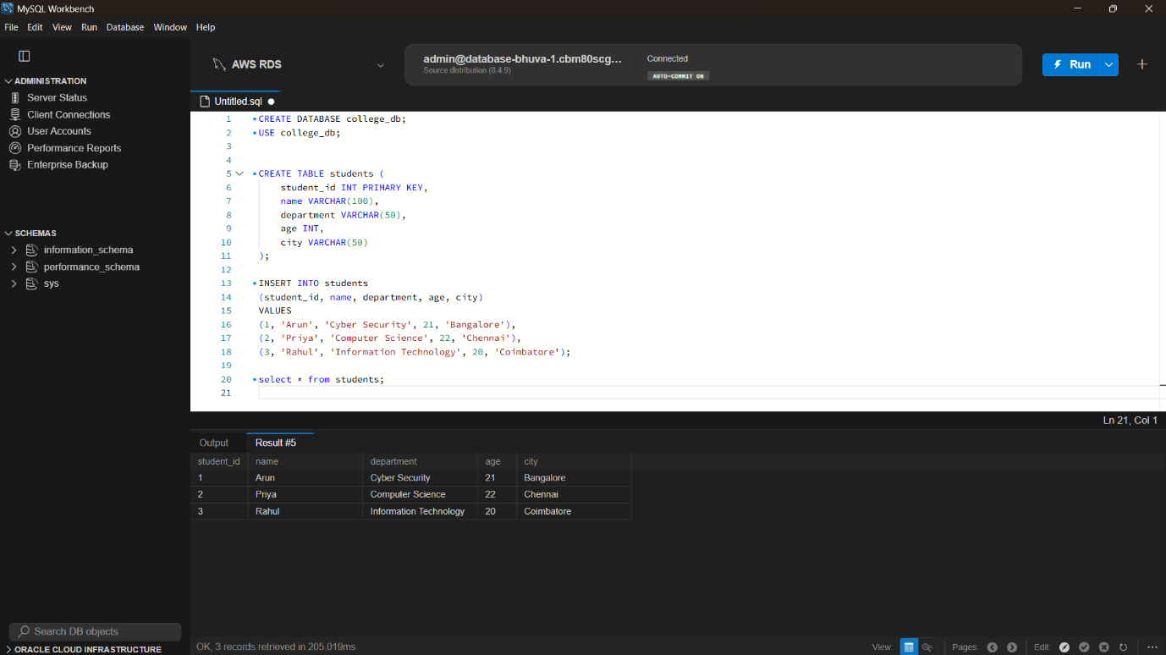

Task 4: AWS CloudWatch – Monitoring and Logs
Open Amazon CloudWatch, select an existing AWS resource or Lambda function, view available metrics or execution logs, and demonstrate the information displayed. Expected output: A metric graph or relevant log entries.
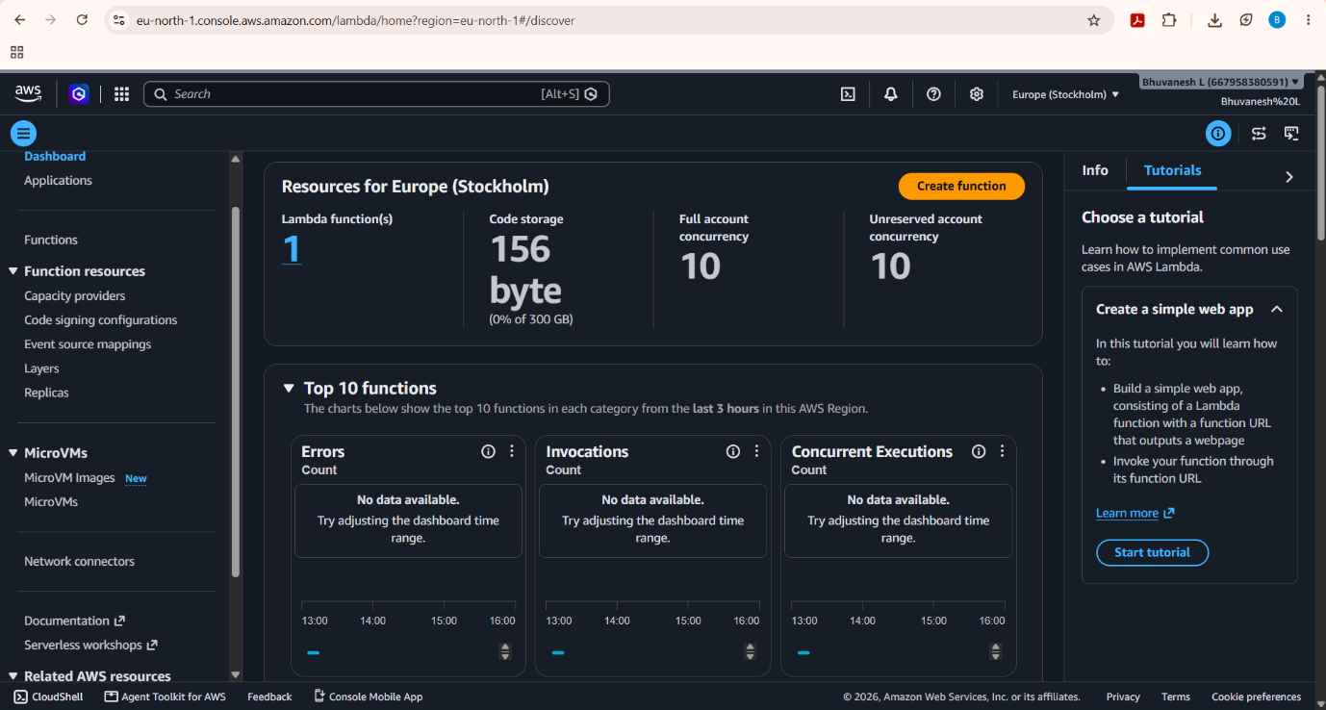

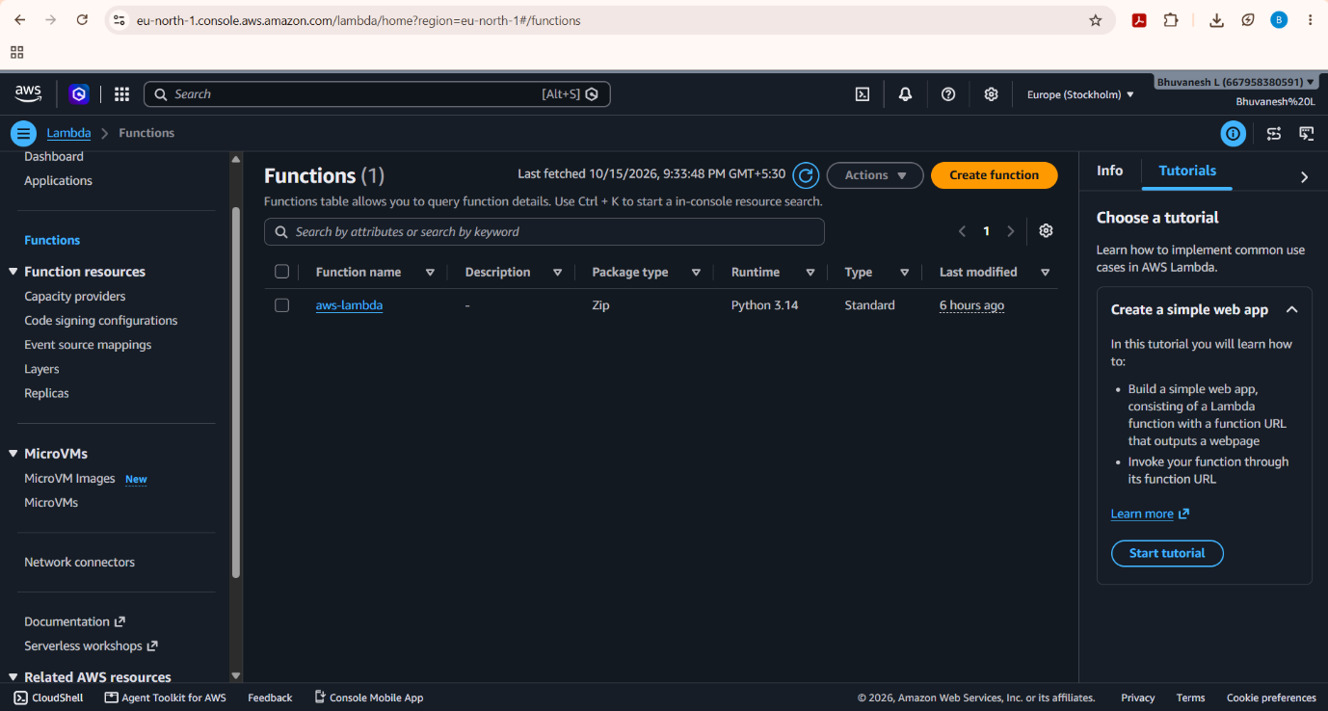

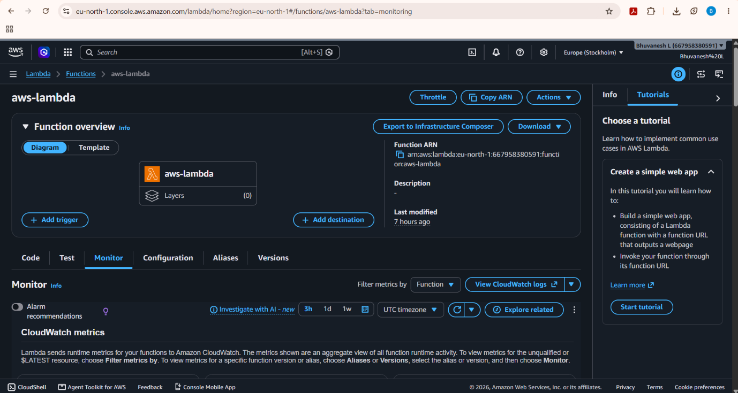

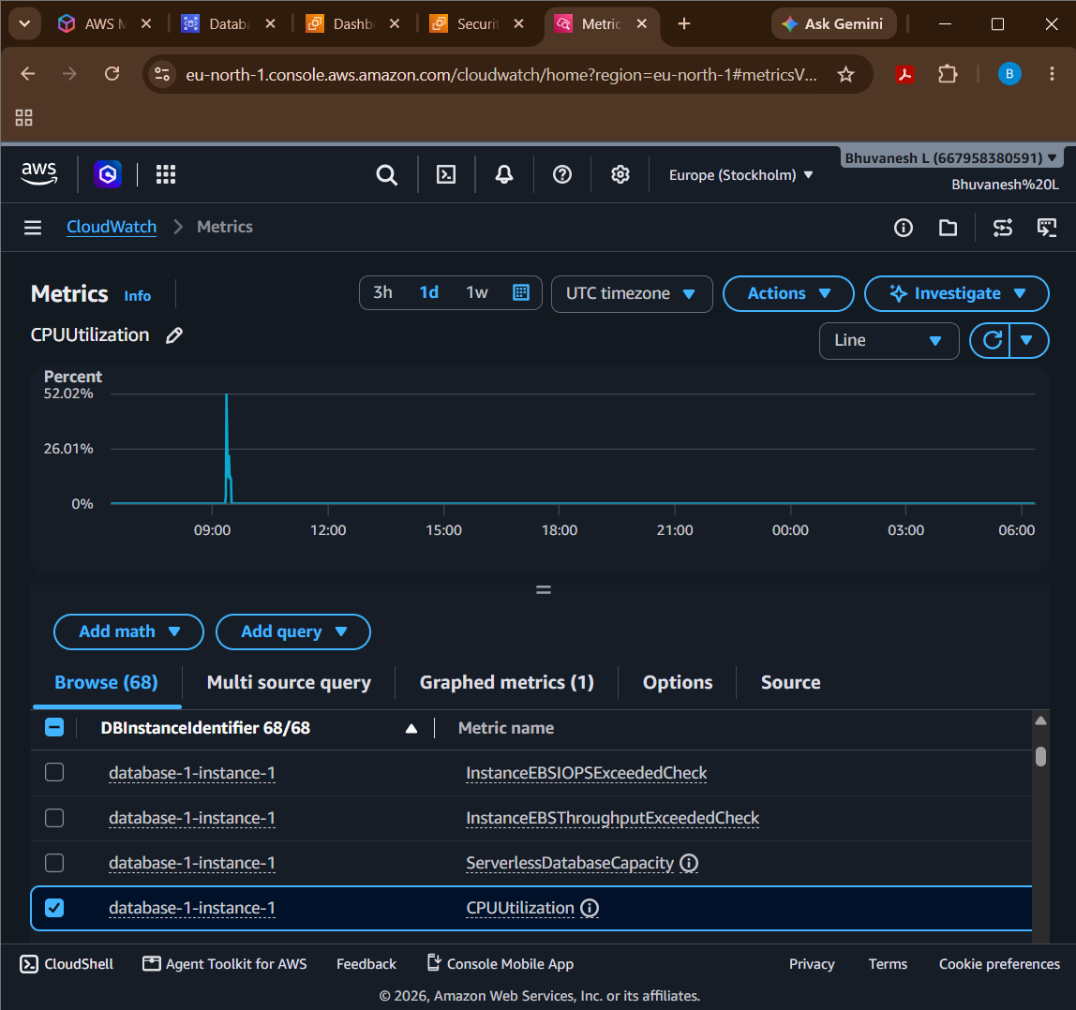

Task 5: Azure Virtual Machine – VM Configuration
Using an existing Azure virtual machine, identify the operating system, display its current status, identify networking details, and demonstrate the VM configuration in the Azure portal. Expected output: The VM's status, operating system, and networking information.
